The Beginning of the Jackson Era
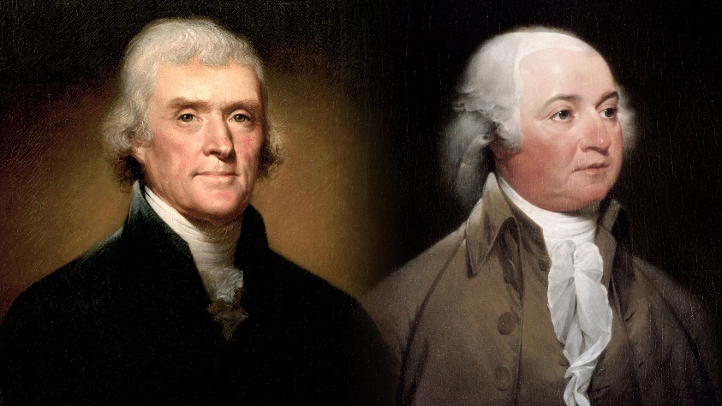
“On the evening of July 3, 1826, a small group of people stood quietly in a darkened room at Monticello, a home in Virginia. They watched as 83-year-olf Thomas Jefferson struggled to breathe. Another group gathered in a darkened bedroom of a house in Quincy, Massachusetts. This group stayed near the bed of 91-year-old John Adams.
In the early dawn hours, Jefferson asked weakly if it was July 4. His friends assured him it was. “Just as I wished,” murmured Jefferson. A few hours later, on the 50th Anniversary of the approval of the Declaration of Independence, Jefferson died. John Adams followed several hours later.
The deaths of these two giants from the American Revolution left people stunned. Clearly, Americans stood on the threshold of a new era. They looked around for leaders to guide the nation on its journey towards greater democracy.” Ritchie, D. and Broussard, A., 1997. American History. New York, N.Y.: Glencoe/McGraw-Hill.

Changes in Political Power
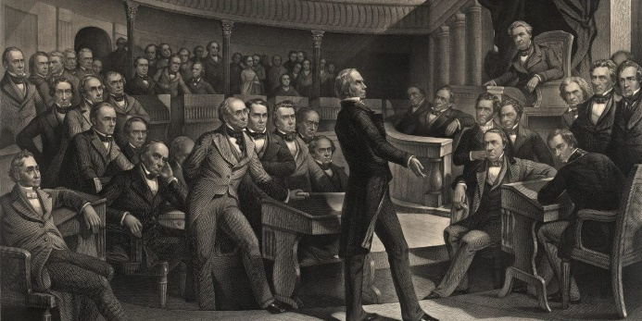
Although the Declaration of Independence stated that “All men are created equal,’ during the early days of the United States only a select group of people – white male property owners – made the decisions about government. As new states began to enter the Union the rules of leadership began to change. In the West, leaders were judged by new standards based on the different way of life in the region. Westerners respected self-made leaders – people who succeeded on their own instead of on inherited wealth or family name. Frontier life was difficult and had taught people in the region the value of hard work and cooperation.
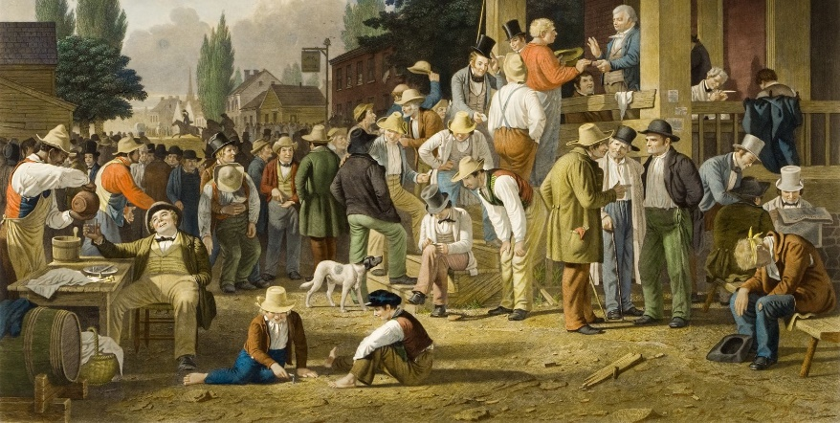
Western states wrote Constitutions that gave the right to vote to all white men. Eventually, states in the East followed the example of the West and began eliminating voting restrictions based on property ownership, payment of taxes, and religion.
As more white free men won the right to vote, many African American men lost it. In the early 1800’s, most Northern states allowed African American men to vote. However, during the 1820’s and 1830’s these states began restrict voting for African Americans. Other groups in the United States that had no voting rights were women, Native Americans, and slaves.

Election of 1824
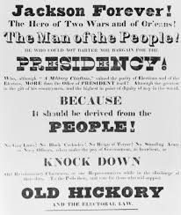
In the 1824 Presidential election, western voters saw two candidates from the West competing for the Presidency, Henry Clay from Kentucky and Andrew Jackson from Tennessee. Clay and Jackson were joined by John Quincy Adams (son of John Adams) from Massachusetts, and William Crawford of Georgia. All 4 candidates ran as Democratic-Republicans as that was the only political party at the time.
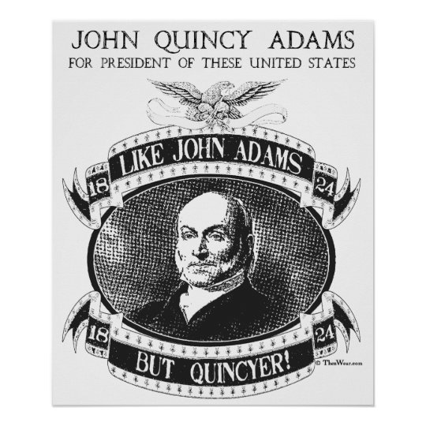
Andrew Jackson won the popular vote but none of the candidates had the majority of the electoral votes. For the second time in history, the House of Representatives had to decide who the President would be. Henry Clay had the fewest votes and was out of the race. William Crawford got sick and dropped out. That left the House choosing between Adams and Jackson. Henry Clay, who was the Speaker of the House, meddled in the election and urged members of the House to support Adams. Many representatives listed to Clay and Adams won. Adams then appointed Clay as his Secretary of State. Jackson’s supporters were angry and claimed that Adams and Clay had made “a corrupt bargain”

Election of 1828
In the Election of 1828, Jackson and Adams ran against each other again. It was a bitter and mean election. Jackson portrayed Adams as a member of the upper class and himself as the common man’s candidate. Jackson accused Adams of favoring stronger federal government power, trying to earn the votes of those who feared federal power. Adams called Jackson “a barbarian and savage who could scarcely spell his own name”. Adams supporters portrayed Jackson as a “ruffian” with a bad temper. On Election Day, Jackson won by a landslide, largely due to those who had recently been allowed to vote such as Eastern workers, farmers in the South, and the people in the Western frontier.
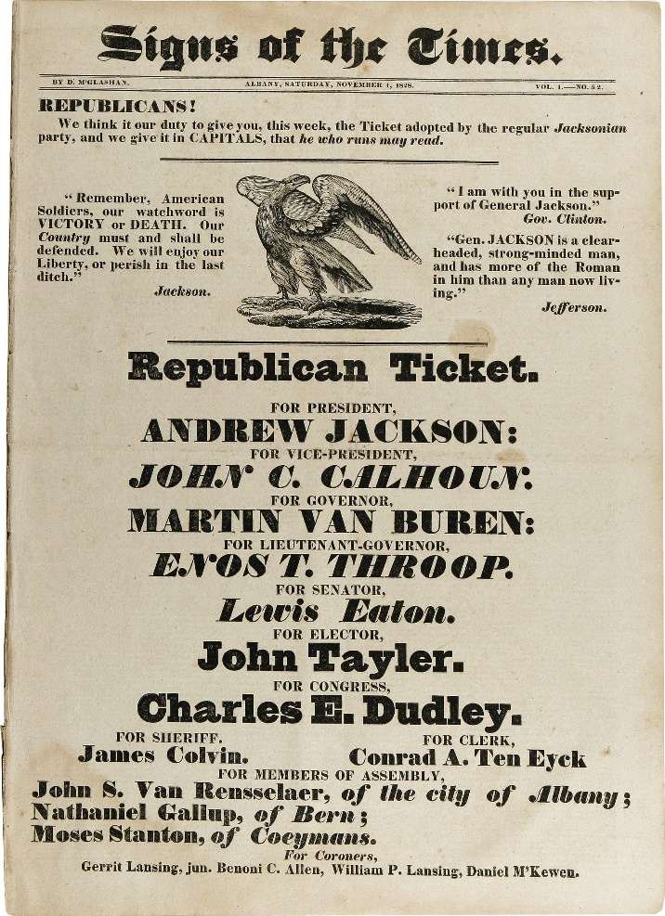
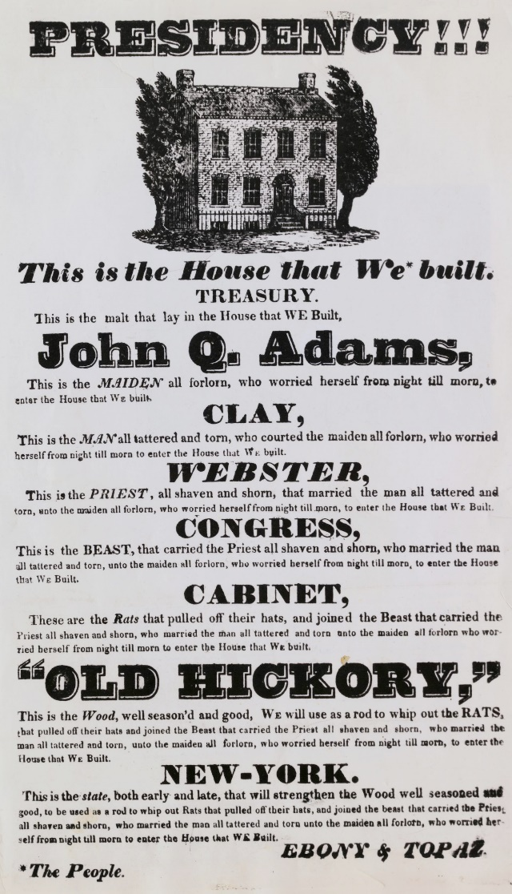

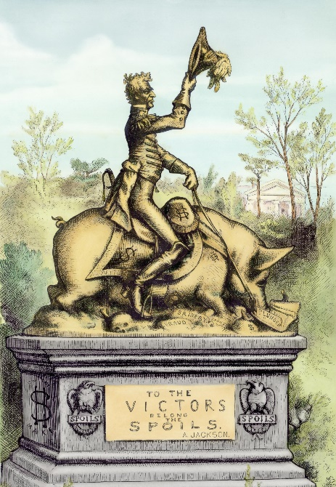
The Spoils System
After Jackson took office, he fired many of the government employees who had worked for Adams and replaced them with his own friends and supporters. This was common with a change in Presidents. Jackson is quoted as saying “To the victor belong the spoils of the enemy” in reference to this practice. What he meant was that by winning the election he could take government jobs from the supporters of his opponent and give them to his own people. Jackson gave out more jobs to his supporters than any other President before him. Because of this, this practice of firing and hiring became known as “The Spoils System”. Jackson thought that this way of doing things expanded democracy and gave more people an opportunity to take part in government.
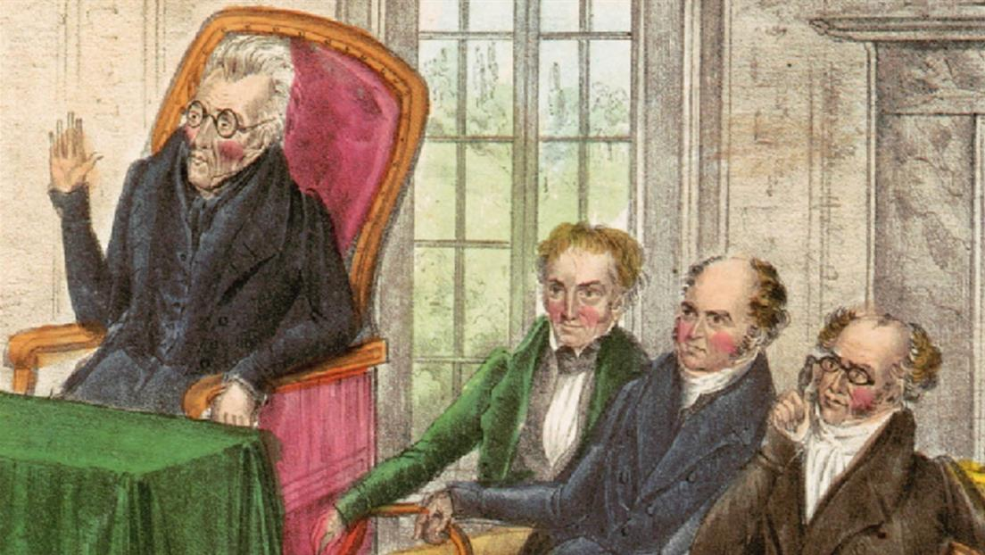
Jackson was known to rely on a group of men who were his personal advisors rather than rely on the cabinet members approved by Congress. Jackson’s group of friends that gave advice earned the nickname “Kitchen Cabinet” by Jackson’s critics. Jackson ignored the criticism of how he did things and said “I do precisely what I think just and right.”

The Tariff of Abominations
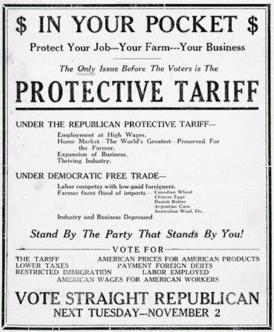
Just before Jackson took office, Congress passed a tariff on imported goods that increased the price of foreign goods sold in the United States. Northern manufacturers and Western farmers liked the tariff but Southern planters did not. The South purchased more imported goods than any other region so the tariff increased the price of nearly everything in the South.
The Southerners nicknamed the tariff “The Tariff of Abominations” and asked Jackson’s Vice President, John Calhoun to fight against it. Calhoun was from South Carolina and he took up the fight against the tariff arguing that each state government had the power to cancel any federal law that the state considered unconstitutional. This brought back the argument of states’ rights versus federal power. It was debated in Congress and within the Whitehouse.
President Jackson had been quiet on the issue of states’ rights. He was from the South and many people assumed that he would side with the southern states. However, Jackson surprised everyone when at a dinner party hosted by states’ rights advocates, he offered a toast that said simply “Our Federal Union – it must be preserved!” Vice President Calhoun came back with a toast saying “The Union – next to our liberty, the most dear!” Calhoun openly placed liberty of the states above the Union. This battle over the tariff and states’ rights led to Calhoun resigning as Vice President at the end of his term. He then ran for Senator of South Carolina and won. With the Vice President spot open, a man named Martin Van Buren ran with Jackson in the 1832 election and became Jackson’s second Vice President.

The Southern Fight for Nullification
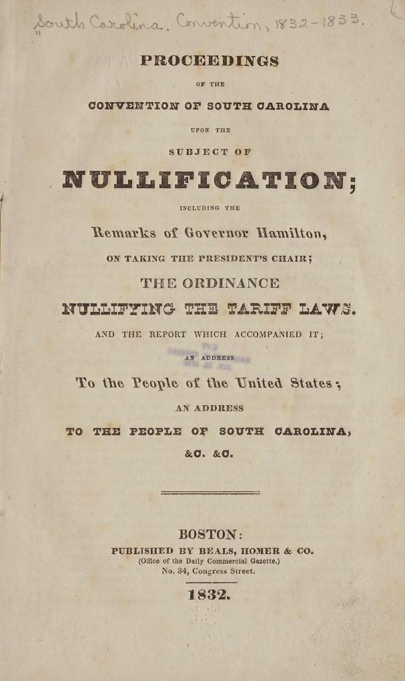
In 1832 Congress passed a new tariff that lowered the rates of the 1828 tariff. The South had been fighting for complete removal of the tariff and was angry. In response, South Carolina passed a state law called the Nullification Act. This law declared the tariff “null, void, and no law”. The people of South Carolina also threatened to secede (leave the Union) if the federal government challenged the new state law.
When Jackson heard about South Carolina, he said he would force the state to uphold the federal law and pay the import taxes. South Carolina had hoped other states would follow their lead and threaten to leave the Union but none did. A compromise was reached in 1833 that lowered the tariff rates again and South Carolina cancelled their Nullification Act. The also paused their intent to secede from the Union.

Native American Policies
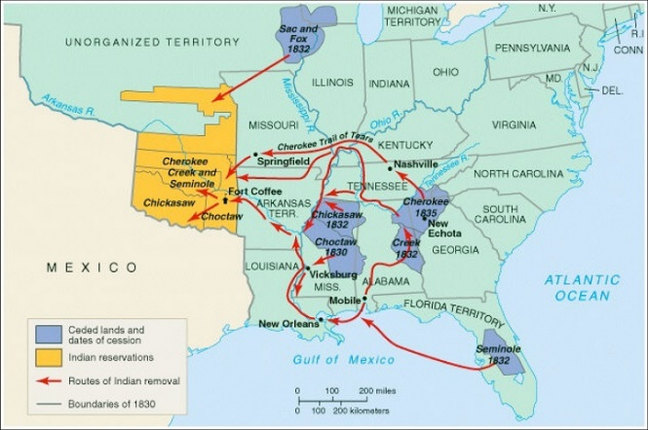
While Jackson did not side with the South on tariffs and nullification, he did agree with them regarding Native Americans. Southerners believed that the Native groups in the south should be forced to resettle west of the Mississippi River so that white settlers and farmers could take over Native lands. Before Jackson ran for President, the federal government had already been backing white settlers who were pushing Natives out. Jackson believed that Native Americans should give up their lands to settlers and that they could live ‘more freely” in an area nicknamed “Indian Territory” (present day Oklahoma).
By the 1820s, there were only approximately 120,000 Native Americans east of the Mississippi River. This included the Choctaw, Chickasaw, Creek, Seminole, and Cherokee Nations. Southern plantation owners had tried to pressure these groups to trade their land in the South for land in the West and leave.
In 1828, the Cherokee asked the Supreme Court to defend the rights of the Native Americans in the Southeast because the state of Georgia had claimed the right to make laws for the Cherokee people. The Cherokee pointed out that treaties they had with the federal government protected the Natives as independent, self-ruling, nations.
During this time, many Cherokee had adopted the customs of white settlers in the area. They had developed a written letter based language, could read and write, published their own newspaper, had written a Constitution, and had set up a representative form of government.
Chief Justice John Marshall sided with the Cherokee in their complaints against Georgia and in 1832, the Supreme Court declared Georgia’s actions against the Cherokee were unconstitutional. President Jackson disagreed and decided to ignore the Supreme Court’s decision. Jackson and his supporters in Congress had passed the Indian Removal Act of 1830 which provided funds for the federal government to remove Native Americans from the eastern United States.

